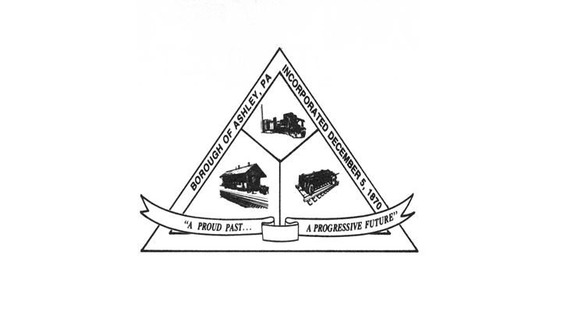

**ASHLEY BOROUGH**

49 West Cemetery St, Ashley, PA 18706

Main Line: (570) 824-1364 Fax Number: (570) 855-1803

Main Office: [ashleyboroughoffice@gmail.com](mailto:ashleyboroughoffice@gmail.com)

Mayor: Brian Demchak

Council President: Lisa Wildes Council Vice President: Andrew Potsko

Carl Byra Frank Sorokach

Jennifer Heller Edward Flynn

Borough Secretary: Lisa Scharer

Code Enforcement Secretary: Amy Campbell

Borough Manager: Samuel Guesto

**ASHLEY BOROUGH COUNCIL MEETING**

**SUMMARY MEETING MINUTES**

AUGUST 12, 2025, 6:40 PM

Attendance:

Lisa Wildes – Present

Andrew Potsko – Present

Carl Byra -- Present

Frank Sorokach – Present

Jennifer Heller – Present

Edward Flynn – Present

Mayor Brian Demchak. – Not Present

Borough Manager Guesto – Present

Borough Secretary Scharer – Present

Police Chief McGlynn – Present   
Code Officer Campbell – Present

The meeting was called to Order by Lisa Wildes. Peter Moses called roll for the Council, Mayor, and Borough Officials.

COUNCIL AND BOROUGH OFFICIAL REPORTS

Lisa Wildes – Nothing for this meeting.

Andrew Potsko – Nothing for this meeting.

Carl Byra – Nothing for this meeting.

Frank Sorokach – Nothing for this meeting.

Jennifer Heller – Jennifer Heller reminded meeting attendees that the community yard sale is going to be held on September 6, 2025. Those that are interested in selling items were instructed to add their address via Facebook to be added to a flyer for patrons.

Edward Flynn – Nothing for this meeting.

Mayor Brian Demchak – Nothing for this meeting.

Secretary Lisa Scharer – Secretary Scharer provided the borough with the Treasurer’s Report, a copy of which is attached hereto and made a part hereof.

Borough Manager Sam Guesto -- Nothing for this meeting.

Chief Joe McGlynn – Chief McGlynn provided the borough with the Police Chief’s Monthly Report, a copy of which is attached hereto and made a part hereof.

Code Officer Amy Campbell – Code Officer Campbell read the Code Officer Report, a copy of which is attached hereto and made a part hereof.

COMMITTEE REPORTS

NONE

ANNOUNCEMENTS

Peter Moses announced that council had the opportunity to meet in executive session and discuss two potential litigation issues.

PUBLIC COMMENT – PENDING LEGISLATION

NONE

LEGISLATION

**RESOLUTION 81 OF 2025** – A Resolution to approve the July 9, 2025, Council Meeting Minutes.

Motion: Lisa Wildes

Second: Andrew Potsko

Lisa Wildes – Y

Frank Sorokach – Y

Carl Byra – Y

Andrew Potsko -- Y

Jennifer Heller – Y

Edward Flynn – Y

PASS

**RESOLUTION 82 OF 2025** – A Resolution to approve the July 2025 bills in the amount of $192,583.67.

Motion: Frank Sorokach

Second: Jennifer Heller

Lisa Wildes – Y

Frank Sorokach – Y

Carl Byra – Y

Andrew Potsko -- Y

Jennifer Heller – Y

Edward Flynn – Y

PASS

**RESOLUTION 83 OF 2025** – A Resolution to approve the July 2025 payroll in the amount of $44,076.50.

Motion: Lisa Wildes

Second: Jennifer Heller

Lisa Wildes – Y

Frank Sorokach – Y

Carl Byra – Y

Andrew Potsko -- Y

Jennifer Heller – Y

Edward Flynn – Y

PASS

**RESOLUTION 84 OF 2025** – A Resolution to approve the Letter of Understanding regarding Ashley Borough Permit Fees for fiberoptic cable and cabinet installation with Corning Optical Communications in the amount of $2,879.00.

Motion: Lisa Wildes

Second: Jennifer Heller

Lisa Wildes – Y

Frank Sorokach – Y

Carl Byra – Y

Andrew Potsko -- Y

Jennifer Heller – Y

Edward Flynn – Y

PASS

**RESOLUTION 85 OF 2025** – A Resolution to approve the payments to Ed Krasavage Construction in the amount of $6,000.00 and Roto Rooter/Richard Tuzinski in the amount of $599.00 to repair a sewer lateral located at 48 Wyoming Street from the Sewer Fee Account. This sewer lateral was damaged by the PA American Water Company project and reimbursement will be requested from them by the Borough Solicitor.

Motion: Frank Sorokach

Second: Jennifer Heller

Lisa Wildes – Y

Frank Sorokach – Y

Carl Byra – Y

Andrew Potsko -- Y

Jennifer Heller – Y

Edward Flynn – Y

PASS

**RESOLUTION 86 OF 2025** – A Resolution to approve Pay Application #1 from Giant Floor in the amount of $11,258.00 for the floor replacement project. This will be reimbursed by the LSA grant award.

Motion: Lisa Wildes

Second: Andrew Potsko

Lisa Wildes – Y

Frank Sorokach – Y

Carl Byra – Y

Andrew Potsko -- Y

Jennifer Heller – Y

Edward Flynn – Y

PASS

**RESOLUTION 87 OF 2025** – A Resolution to approve the 2025/2026 Winter Maintenance Agreement with PennDOT in the amount of $8,583.14

Motion: Lisa Wildes

Second: Jennifer Heller

Lisa Wildes – Y

Frank Sorokach – Y

Carl Byra – Y

Andrew Potsko -- Y

Jennifer Heller – Y

Edward Flynn – Y

PASS

**RESOLUTION 88 OF 2025** -- A Resolution, upon the recommendation of the Borough Engineer, approving Change Order No. 3 with RLE in the amount of $102,968.80 for the Solomon’s Creek Interceptor Rehabilitation Project. This is for unforeseen conditions within the 100-year-old pipe. This has been reviewed by the Borough Solicitor. This will be paid for by the Luzerne County ARPA Grant Fund.

Motion: Frank Sorokach

Second: Edward Flynn

Lisa Wildes – Y

Frank Sorokach – Y

Carl Byra – Y

Andrew Potsko -- Y

Jennifer Heller – Y

Edward Flynn – Y

PASS

**RESOLUTION 89 OF 2025** – A Resolution to appoint James Barberio to the Zoning Hearing Board as an alternate member effective August 13, 2025.

Motion: Jennifer Heller

Second: Lisa Wildes

Lisa Wildes – Y

Frank Sorokach – Y

Carl Byra – Y

Andrew Potsko -- Y

Jennifer Heller – Y

Edward Flynn – Y

PASS

PUBLIC COMMENT

**TOM KNEIDINGER OF 17 SOUTH MAIN STREET:** The amount of rain over the course of July caused flooding in Mr. Kneidinger’s basement as well as the road he resides due to congested drains. Mr. Kneidinger is requesting that borough workers get involved prior to flooding and block a traffic lane to clean the drains.

Peter Moses responded that the Borough Manager has Mr. Kneidinger’s phone number and will address the issue.

______________________________________________________________________________  
  
MOTION TO ADJOURN

Motion: Lisa Wildes

Second: Jennifer Heller

MEETING ADJOURNED