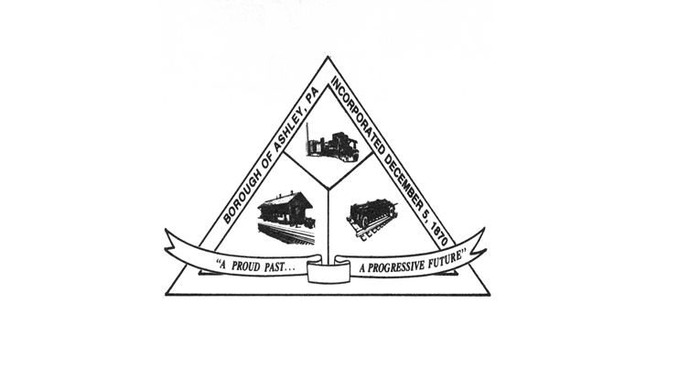

**ASHLEY BOROUGH**

49 West Cemetery St, Ashley, PA 18706

Main Line: (570) 824-1364 Fax Number: (570) 855-1803

Main Office: [ashleyboroughoffice@gmail.com](mailto:ashleyboroughoffice@gmail.com)

Mayor: Brian Demchak

Council President: Lisa Wildes Council Vice President: Andrew Potsko

Carl Byra Frank Sorokach

Jennifer Heller Edward Flynn

Borough Secretary: Lisa Scharer

Code Enforcement Secretary: Amy Campbell

Borough Manager: Samuel Guesto

**ASHLEY BOROUGH COUNCIL**

**SUMMARY WORK SESSION MINUTES**

JULY 09, 2025, 6:30 PM

Attendance:

Lisa Wildes – Present

Andrew Potsko – Present

Carl Byra –Not Present

Frank Sorokach – Present

Jennifer Heller – Present

Edward Flynn – Present

Mayor Brian Demchak. – Present

Borough Manager Guesto – Not Present

Borough Secretary Scharer – Present

Police Chief McGlynn – Not Present   
Code Officer Campbell – Present

The meeting was called to Order by Lisa Wildes. Herbert Nahas called roll for the Council, Mayor, and Borough Officials. The Pledge of Allegiance was recited by all.

COUNCIL AND BOROUGH OFFICIAL PRESENTATIONS

Lisa Wildes – Nothing for this meeting.

Andrew Potsko – Nothing for this meeting.

Carl Byra – Not present for this meeting.

Frank Sorokach – Nothing for this meeting.

Ms. Heller – Nothing for this meeting.

Mr. Flynn – Nothing for this meeting.

Mayor Demchak – Nothing for this meeting.

Secretary Lisa Scharer – Nothing for this meeting.

Borough Manager Guesto -- Not present for this meeting.

Chief Joe McGlynn – Not present for this meeting.

Code Officer Amy Campbell – Nothing for this meeting.

Herbert Nahas announced the future meeting date(s):

August 12, 2025,

6:30 PM Work Session

6:40 PM Council Meeting.

______________________________________________________________________________  
  
MOTION TO ADJOURN

Motion: Lisa Wildes

Second: Jennifer Heller

MEETING ADJOURNED