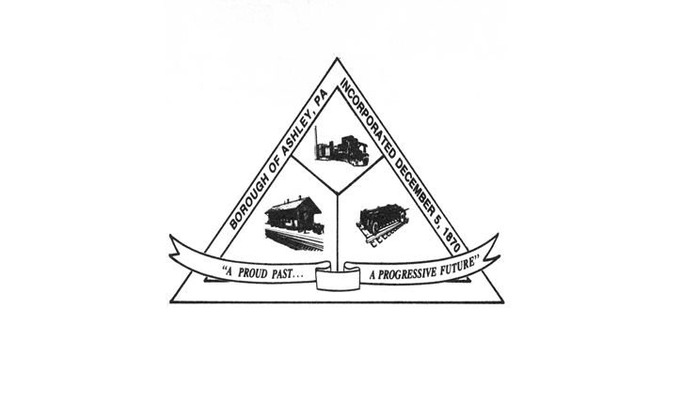

**ASHLEY BOROUGH**

49 West Cemetery St, Ashley, PA 18706

Main Line: (570) 824-1364 Fax Number: (570) 855-1803

Main Office: [ashleyboroughoffice@gmail.com](mailto:ashleyboroughoffice@gmail.com)

Mayor: Brian Demchak

Council President: Lisa Wildes Council Vice President: Andrew Potsko

Carl Byra Frank Sorokach

Jennifer Heller Edward Flynn

Borough Secretary: Lisa Scharer

Code Enforcement Secretary: Amy Campbell

Borough Manager: Samuel Guesto

**ASHLEY BOROUGH COUNCIL MEETING AGENDA**

JULY 08, 2025, 6:40 PM

1. Call to Order
2. Roll Call

* Ms. Wildes
* Mr. Potsko
* Mr. Byra
* Mr. Sorokach
* Ms. Heller
* Mr. Flynn
* Mayor Demchak
* Borough Manager Guesto
* Chief McGlynn
* Secretary Scharer
* Code Officer Campbell

1. Council Member Reports

* Ms. Wildes
* Mr. Potsko
* Mr. Byra
* Mr. Sorokach
* Ms. Heller
* Mr. Flynn

1. Mayor’s Report
2. Borough’s Secretary Report
3. Treasurer’s Report to be presented by Secretary Scharer
4. Police Chief’s Report
5. Code Officer’s Report
6. Legislation
7. Announcements
8. Public Comment – Pending Legislation Only

**RESOLUTION 73 OF 2025** – A Resolution to approve the June 10, 2025, Council Meeting Minutes.

**RESOLUTION 74 OF 2025** – A Resolution to approve the June 2025 bills in an amount not to exceed $100,000.00.

**RESOLUTION 75 OF 2025** – A Resolution to approve the June 2025 payroll in an amount not to exceed $100,000.00.

**RESOLUTION 76 OF 2025** -- A Resolution, upon the recommendation of the Borough Engineer, approving Payment Application No. 1 with the Specialty Fence in the amount of $10,925.00 for the Municipal Building Renovation Project. This will be reimbursed by the LSA Grant Award.

**RESOLUTION 77 OF 2025** -- A Resolution, upon the recommendation of the Borough Engineer, approving Payment Application No. 1 with Rowe Garage Door Co. in the amount of $6,225.00 for the Municipal Building Renovation Project. This will be reimbursed by the LSA Grant Award.

**RESOLUTION 78 OF 2025** – A Resolution, upon the recommendation of the Borough Engineer, approving Payment Application No. 3 with RLE in the amount of $389,711.12 for the Solomon’s Creek Interceptor Rehabilitation Project. This will be paid for by the Luzerne County ARPA Grant Fund.

**RESOLUTION 79 OF 2025** – A Resolution, upon the recommendation of the Borough Engineer, approving Change Order No. 5 with RLE in the amount of $6,355.20 for the widening of the opening of Manhole No. 14 for the Solomon’s Creek Interceptor Rehabilitation Project. This will be paid for by the Luzerne County ARPA Grant Fund.

**RESOLUTION 80 OF 2025** – A Resolution, upon the recommendation of the Borough Engineer, approving Change Order No. 6 with RLE in the amount of a credit of $32,121.41 for the scope of work change to Change Order No. 1 for Manhole No. 14A for the Solomon’s Creek Interceptor Rehabilitation Project. This will be returned to the Luzerne County ARPA Grant Fund.

1. Public Comment
2. Adjournment