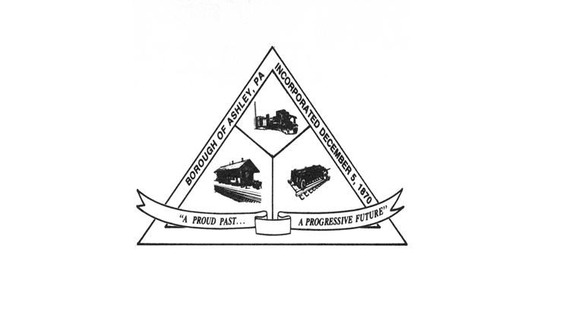

**ASHLEY BOROUGH**

49 West Cemetery St, Ashley, PA 18706

Main Line: (570) 824-1364 Fax Number: (570) 855-1803

Main Office: [ashleyboroughoffice@gmail.com](mailto:ashleyboroughoffice@gmail.com)

Mayor: Brian Demchak

Council President: Lisa Wildes Council Vice President: Andrew Potsko

Carl Byra Frank Sorokach

Jennifer Heller Edward Flynn

Borough Secretary: Lisa Scharer

Code Enforcement Secretary: Amy Campbell

Borough Manager: Samuel Guesto

**ASHLEY BOROUGH WORK SESSION AGENDA**

AUGUST 12, 2025, 6:30 PM

1. Call to Order
2. Roll Call

* Ms. Wildes
* Mr. Potsko
* Mr. Byra
* Mr. Sorokach
* Ms. Heller
* Mr. Flynn
* Mayor Demchak
* Borough Manager Guesto
* Chief McGlynn
* Secretary Scharer
* Code Officer Campbell

1. Pledge of Allegiance
2. Council Member Presentations

* Ms. Wildes
* Mr. Potsko
* Mr. Byra
* Mr. Sorokach
* Ms. Heller
* Mr. Flynn

1. Additional Presentations

-Future meeting date(s): September 9, 2025, at 6:30 PM Work Session and 6:40 PM Council Meeting

Motion to Adjourn