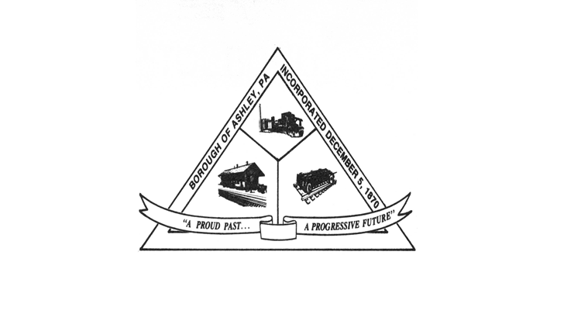

ASHLEY BOROUGH
49 Cemetery St, Ashley, PA 18706
Main Line: (570) 824-1364 Fax Number: (570) 855-1803
Main Office: ashleyboroughoffice@gmail.com
Mayor: Brian Demchak
Council President: Lisa Wildes Council Vice President: Andrew Potsko
Carl Byra Frank Sorokach
Jennifer Heller Edward Flynn
Borough Secretary: Lisa Scharer
Code Enforcement Secretary: Amy Campbell
Borough Manager: Samuel Guesto
ASHLEY BOROUGH SPECIAL HEARING AGENDA
September 18, 1:30 PM
- Call to Order
- Roll Call
  - Ms. Wildes
  - Mr. Potsko
Mr. Byra
  - Mr. Sorokach
  - Ms. Heller
  - Mr. Flynn
  - Mayor Demchak
  - Borough Manager Guesto
  - Chief McGlynn
  - Secretary Scharer
  - Code Officer Campbell
- Solicitor’s Report
- RESOLUTION 99 OF 2025- A resolution that the Borough manager, as established per State requirement, is informing the Borough Council and Mayor that the Minimum Municipal Obligation (MMO), for the police pension for 2026 is $0 (zero dollars). This satisfies all reporting requirements.
- RESOLUTION 100 OF 2025- A resolution, upon the recommendation of the borough Engineer, to approve Pay Application #4 for the Solomon’s Creek Interceptor Project to RLE Enterprises in the amount of $427,791.60 from the ARPA account.
- Public Comment
- Adjourn

