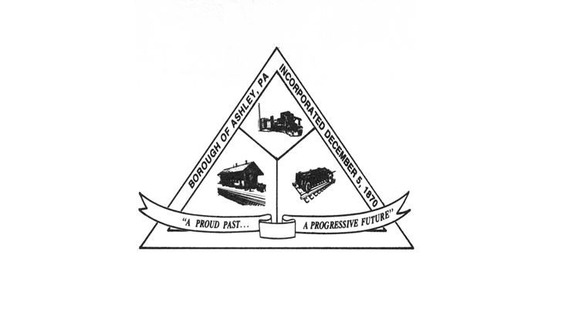

**ASHLEY BOROUGH**

49 West Cemetery St, Ashley, PA 18706

Main Line: (570) 824-1364 Fax Number: (570) 855-1803

Main Office: [ashleyboroughoffice@gmail.com](mailto:ashleyboroughoffice@gmail.com)  
Mayor: Brian Demchak

Council President: Lisa Wildes Council Vice President: Andrew Potsko

Carl Byra Frank Sorokach

Jennifer Heller Edward Flynn

Borough Secretary: Lisa Scharer

Code Enforcement Secretary: Amy Campbell

Borough Manager: Samuel Guesto

**BOROUGH COUNCIL MEETING AGENDA**

**Tuesday, May 14, 2024 – 6:30 P.M.**

1. Call to Order

(b) Roll Call

* Ms. Wildes
* Mr. Potsko
* Mr. Byra
* Mr. Sorokach

- Ms. Heller

- Mr. Flynn

- Mayor Demchak

- Manager Guesto

- Secretary Scharer

- Chief McGlynn

- Code Officer Campbell

(c) Pledge of Allegiance

(d) Council Member Reports

* Ms. Wildes
* Mr. Potsko
* Mr. Byra
* Mr. Sorokach
* Ms. Heller
* Mr. Flynn

(e) Mayor’s Report

(f) Borough Secretary’s Report

(g) Police Chief’s Report

1. Code Officer’s Report

(i) Legislation

Public Comment – Pending Legislation Only

**RESOLUTION 55 OF 2024** – A Resolution to approve the April 9, 2024 Council Meeting Minutes.

**RESOLUTION 56 OF 2024** – A Resolution to approve the April 2024 bills in an amount not to exceed $200,000.00.

**RESOLUTION 57 OF 2024** – A Resolution to approve the April 2024 payroll in an amount not to exceed $100,000.00.

**RESOLUTION 58 OF 2024**- A Resolution authorizing the proposal from Spinnaker Insurance company in the amount of $2,581.00 for cybersecurity insurance premium.

**RESOLUTION 59 OF 2024-** A Resolution authorizing the lease proposal from Golden Business Machines in the amount of $81.25 per month for 60 months for a Cannon desktop copier.

**RESOLUTION 60 OF 2024-** A Resolution approving the application and plan for the minor subdivision for 121 North Main Street (American Legion Post 673).

**RESOLUTION 61 OF 2024-** A Resolution to approve Ordinance Number 1 of 2024, the adoption of the amendment to the Ashley Borough Zoning Ordinance of June 13, 2016 for Floodplain Map policies as advertised.

**RESOLUTION 62 OF 2024-** A Resolution ratifying the proposal from Synergistic Networks in the amount of $4,600.00 for 40 hours of technical consulting for QuickBooks setup and other information technology services.

**RESOLUTION 63 OF 2024-** A Resolution to pay the invoice from Reilly & Associates in the amount of $10,613.75 for the Garage Door Replacement Project and to request grant reimbursement for the expense.

**RESOLUTION 64 OF 2024-** A Resolution to pay the invoice from Reilly & Associates in the amount of $19,711.25 for the Municipal Building Roof Replacement Project and to request grant reimbursement for the expense.

**RESOLUTION 65 OF 2024-** Resolution to authorize the submission of a Multimodal Fund Grant for the Mainstreet Streetscape Project Phase II.

**RESOLUTION 66 OF 2024-** A Resolution to authorize the submission of a Greenways, Trails and Recreation Grant for the Conyngham Street Playground Project.

**RESOLUTION 67 OF 2024-** A Resolution to authorize the submission of request to PennDOT to include Ashley Borough in the Bundling Agreement for the PennDOT Metropolitan Planning Organization (MPO) funding for Carey and Rodgers Street Bridges and design and engineering.

**RESOLUTION 68 OF 2024-** A Resolution to ratify all payments of wages to Part Time Police Officer David Fedorczyk to date and authorization to pay him overtime rates as applicable and authorized by the Chief of Police.

**RESOLUTION 69 OF 2024-** A Resolution to authorize the donation of $500.00 to the American Legion for the Memorial Day Parade.

**RESOLUTION 70 OF 2024-** A Resolution ratifying the proposal for financial services from Hazleton Business & Payroll Solutions, Inc. in the amount of $9,500.00 plus $110.00 per hour for non-scoped services.

**RESOLUTION 71 OF 2024-** A Resolution to award the Luzerne County Office of Community Development funding paving project to Barker & Barker Paving for the Base Bid, Alternate 1 and Alternate 2 in the amount of $147,623.00. This includes East Hartford Street, Church and School Lanes and the basketball courts at Conyngham Street playground.

(m) Public Comment

(n) Adjournment